EXAM STRESS AND ITS IMPACT ON ACADEMIC PERFORMANCE.
Submitted by: Mahesh Bharambe , Aachal Patil
Course: MCA 2nd Year
Guide Name : Prof.Shubham Adawal
Abstract
This study investigates the link between examination stress and academic performance among 109 students. Exam stress was measured using a standardized Likert-scale questionnaire, while academic performance was assessed through recent exam scores. Most students reported experiencing exam stress, primarily due to lack of preparation time (42.2%) and poor time management (21.1%). Other contributing factors included peer competition (13.8%), health issues (11%), and financial difficulties (5.5%), with 6.4% citing other causes. The findings show that exam stress is widespread and impacts students’ academic outcomes. The study recommends interventions such as relaxation techniques, counseling, and structured study planning to help manage stress and improve performance.
Objective:
- Identify causes of exam stress, including performance pressure, fear of failure, parental expectations, and time constraints.
- Analyze the occurrence and degree of stress faced by learners during exams..
- Investigate how examination stress influences academic performance.
- Explore coping strategies used by students, such as time management, relaxation, or counseling.
- Investigate differences in exam stress based on demographics like age, gender, academic year, or field of study.
Methods: This study employed a quantitative survey-based research design to examine the relationship between exam stress and academic performance among students.Sample size: 100 students. Sampling method: Stratified random sampling (to ensure representation of male and female students from different years of study).

Abstract
This study explores the relationship between examination stress and academic performance among 109 students. Exam stress was assessed using a standardized Likert-scale stress questionnaire, while academic performance was measured through recent exam scores. Findings indicate that a majority of students experience exam-related stress, primarily due to lack of preparation time (42.2%) and poor time management (21.1%). Additional contributing factors include competition with peers (13.8%), health issues (11.0%), and financial difficulties (5.5%). A smaller proportion (6.4%) reported other unspecified causes. The results highlight the need for targeted interventions, such as relaxation techniques, counseling, and structured study planning, to help students manage stress effectively and enhance academic performance.
Objective: To investigate the differences in exam stress based on demographics.
Compare stress levels across age groups, gender, academic year, or field of study.
Methods: This study employed a quantitative survey-based research design to examine the relationship between exam stress and academic performance among students.Sample size: 100 students. Sampling method: Stratified random sampling (to ensure representation of male and female students from different years of study).
Results: (Sample Size: 109 Students) The findings reveal that the majority of students experience exam-related stress due to multiple factors. Among the 109 respondents, the most commonly reported cause of stress was lack of preparation time (42.2%), followed by poor time management (21.1%). Other significant contributors include competition with peers (13.8%), health issues (11.0%), and financial problems (5.5%). A small proportion of
Keywords : Exam Stress, Academic Performance.

Introduction
Exam stress refers to the anxiety or pressure students feel while preparing for or taking exams,tests,assignments, or presentations.Some stress can be helpful, as it encourages students to prepare and stay focused. However, too much stress can make it difficult to concentrate, learn, and perform well academically. Studies show that exam periods, especially oral exams, can be very stressful, causing worry, anxiety, sleep problems, forgetfulness, irritability, fatigue, and a sense of being overwhelmed.
Academic performance reflects the degree of success students attain in their educational pursuits. It is often measured through grades, exam results, or overall school achievement. Doing well in school is important for students’ growth, helping them develop socially and prepare for future careers and life challenges.Stress affects both the mind and the body. Mild stress can improve focus and performance, but long-term high stress can lead to anxiety, depression, and other health problems. To help students cope, schools and colleges can offer relaxation activities, counseling, and guidance on study planning. Academic performance remains a key part of a student’s education and overall development.
Problem Statement: Examination periods often cause high stress among students, impacting their memory, concentration, and overall well-being. While moderate stress can motivate, excessive stress leads to anxiety, depression, and physical health issues. The academic focus on grades and competition, coupled with limited mental health support, intensifies the problem. Many students also lack effective coping strategies to manage exam-related pressures.

Outcome: The study aims to identify major exam stressors like performance pressure, fear of failure, and parental expectations, while measuring stress levels and their negative impact on academic performance. It will explore coping strategies such as time management, group study, and counseling, and examine variations in stress across gender, academic year, and field of study. The research highlights the need for institutional support through counseling, workshops, and awareness programs, and will recommend strategies to reduce exam-related stress and promote a healthier academic environment.
Literature Review :
Lin and Chen (1995) reported that academic pressure has adverse effects on students’ cognitive, emotional, and physical growth.The study emphasized how persistent stress can lead to burnout and reduced motivation to study. It also noted that stress influenced students' overall engagement with academic activities and performance.
According to Cheng (1999), pressure from parents, teachers, and self-expectations often caused stress among students, leading to distress.This pressure often resulted in emotional strain and decreased self-confidence during exam periods. The findings highlighted the role of unrealistic academic standards in creating long-term stress.
Lee & Larson (2000) High examination stress reduced students’ social interactions and engagement in leisure activities, increasing the negative impact of stress. Limited time for recreation negatively affected students' ability to relax and recharge mentally. This imbalance led to heightened anxiety and a sense of social withdrawal during examination periods.
Brown & Ralph (1999) Found that students suffer significant levels of stress, with exams being a primary factor contributing to psychological strain. Stress levels were found to be severe enough to impair attention, memory, and problem-solving abilities. They recommended institutional interventions to help students develop coping mechanisms.
Banerjee (2001) Reported that approximately 25,000 students aged 18–20 commit suicide annually during exam months (March to June) in India, highlighting the severity of exam stress. The data underscores the urgent need for systemic changes in academic expectations and mental health awareness. It also highlights how societal pressure and stigma can make students feel trapped and hopeless.

Rana & Mahmood (2010)
Demonstrated that cognitive factors such as worry contribute more to test anxiety than emotional ones, directly impacting academic performance. The study suggests that helping students manage their thoughts and expectations could reduce anxiety. They concluded that targeted training programs could help students regulate exam-related worries effectively.
Saima R & Qadir B (2011)
Found that exam hall environment, attendance, exam patterns, and invigilator behavior significantly affect university students’ academic performance. Psychological and physical discomfort in the exam setting increased stress levels and lowered focus. This points to the need for standardized, student-friendly examination procedures.
Kumari & Gartia (2012)
This imbalance led to heightened anxiety and a sense of social withdrawal during examination periods.Students under mild to moderate stress appeared more focused and goal-driven. However, excessive stress led to diminishing academic outcomes and mental health concerns.
Jayanthi et al. (2014)
Identified parental and teacher expectations as key sources of academic stress among adolescents, with girls showing higher stress levels. High achievers often internalized stress due to fear of letting others down. The study emphasized the importance of emotional support systems for students.
Prabu (2015)
Found that male, urban, and private school students, particularly those studying science, experienced higher academic stress. Stress levels varied significantly with subject choice, school environment, and parental literacy. The study suggested that curriculum pressure and peer competition were major contributing factors.
Kumari & Singh (2022)
Found significant differences in academic stress by gender and school type, with missionary school students experiencing the highest stress levels. No significant stress differences were found among students from different academic streams.
Data Collection and analysis : Data Collection and Analysis: In this study, information was collected using both primary and secondary sources. Primary data was obtained through questionnaires filled out by students, while secondary data came from websites, research articles, surveys, and reports. A total of 109 students from different areas of Jalgaon were chosen to represent a variety of backgrounds. The questionnaire included straightforward, multiple-choice, and close-ended questions to collect clear and relevant responses.
Gender:
Gender | Number | Proportion %
Male | 56 | 51.4%
Female | 53 | 48.6%
Transgender | 0 | 0%
Total | 109 | 100%

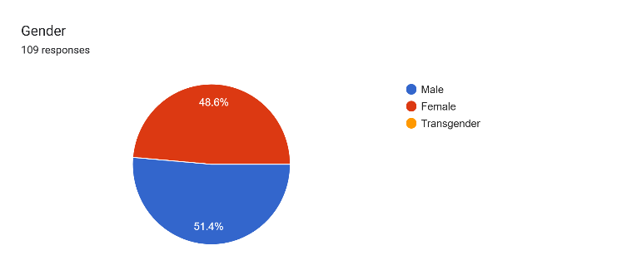Conclusion: Male participants (51.4%) slightly outnumbered females (48.6%), while no respondents identified as transgender.
Interpretation: The gender ratio is nearly balanced with slight male dominance, while transgender representation is absent, likely due to low visibility or non-disclosure.
- Academic Year:
Academic Year | Number | Proportion %
1st year | 20 | 18.3%
2nd year | 26 | 23.9%
3rd year | 12 | 11%
Final | 21 | 19.3%
Postgraduate | 30 | 27.5%
Total | 109 | 100%

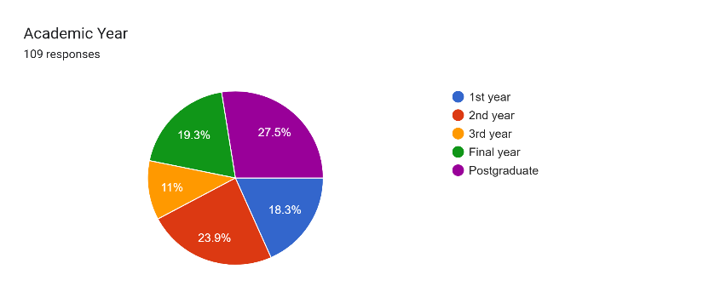 Conclusion: Most respondents were postgraduates (27.5%), while the lowest were from 3rd year (11%). Others included 2nd year (23.9%), final year (19.3%), and 1st year (18.3%).
Interpreatation: The sample spans all academic years, with postgraduates largest and 3rd-year students least, ensuring diverse and comprehensive perspectives.
- Field of study:
Field of study | Number | Proportion %
Science | 47 | 43.1%
Commerce | 9 | 8.3%
Arts | 3 | 2.8%
Engineering | 18 | 16.5%
Other | 32 | 29.4%
Total | 109 | 100%

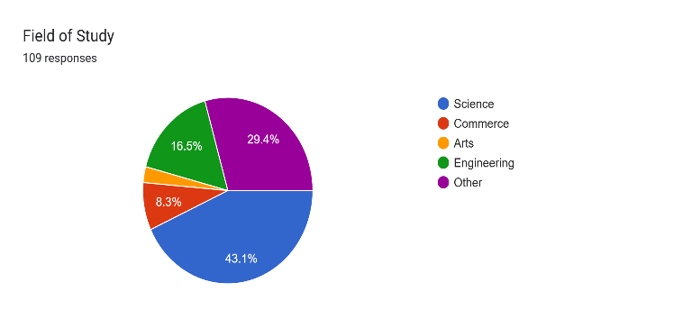Conclusion: Science students form the largest group (43.1%), while Arts has the least representation (2.8%). Other groups include Engineering (16.5%), Commerce (8.3%), and Other fields (29.4%).
Interpretation: The sample is diverse academically, with most students in Science, followed by Other fields and Engineering, and fewer in Commerce and Arts, showing a slight Science skew.
- Type of institution:
Type of Institution | Number | Proportion %
Government | 30 | 27.5%
Private | 79 | 72.5%
Total | 109 | 100%

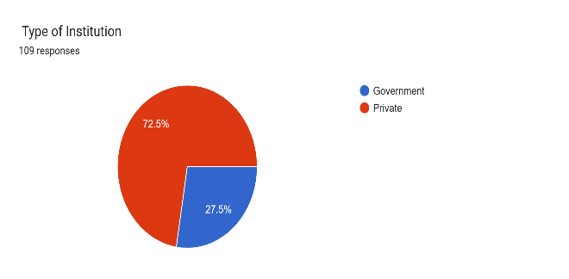Conclusion: Most respondents are from private institutions (72.5%), while a smaller share (27.5%) study in government institutions.
Interpretation: The sample is mostly private institution students, with some from government institutions, allowing for comparative insights.
- How often do you fear failing an exam?
How often do you fear failing an exam? | Number | Proportion %
Never | 36 | 33%
Rarely | 25 | 22.9%
Sometimes | 40 | 36.7%
Always | 8 | 7.3%
Total | 109 | 100%

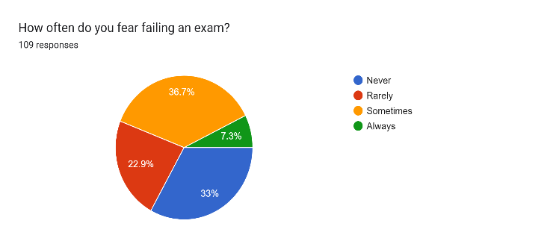Conclusion: Most students responded "Sometimes" (36.7%), followed by "Never" (33%). "Rarely" (22.9%) indicates moderate concern, while a small group (7.3%) reported constant fear of failure.
Interpretation: Most students experience occasional exam fear, while a small minority face constant anxiety, showing varied stress levels.
- Which of the following cause you stress during exams?
Which of the following cause you stress during exams? | Number | Proportion %
Lack of preparation time | 46 | 42.2%
Competition with peers | 15 | 13.8%
Poor time management | 23 | 21.1%
Health Issues | 12 | 11%
Financial problems | 7 | 6.4
Other | 6 | 5.5%
Total | 109 | 100%

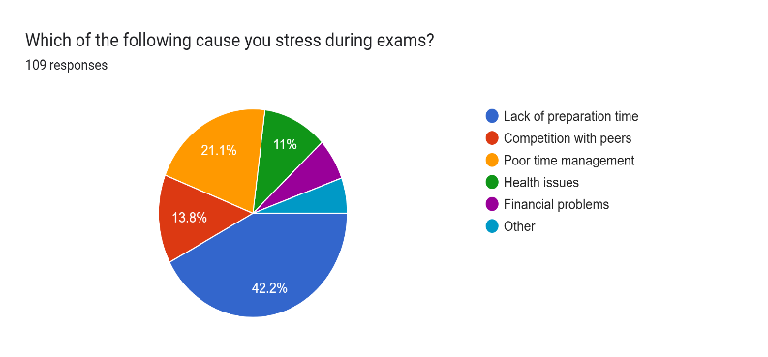Conclusion: The leading stress factor is lack of preparation time (42.2%), followed by poor time management (21.1%). Other causes include competition (13.8%), health issues (11%), financial problems (6.4%), and a few reporting other reasons (5.5%).
Interpretation: Exam stress is mainly driven by academic factors like poor preparation and time management, with other issues playing a smaller role.
- During exam periods, how often do you experience difficulty sleeping?
During exam periods, how often do you experience difficulty sleeping? | Number | Proportion %
Never | 23 | 21.1%
Always | 30 | 27.5%
Sometimes | 39 | 35.8%
Rarely | 17 | 15.6%
Total | 109 | 100%

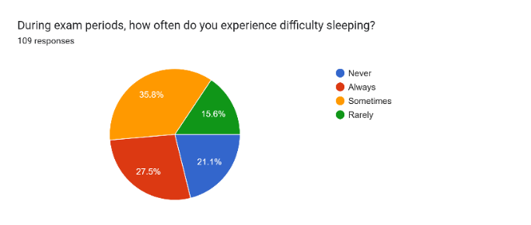Conclusion: Most students face sleep disturbances during exams, mainly “sometimes” or “always.” A few remain unaffected, while those with constant issues form a vulnerable group, showing sleep problems as a common sign of exam stress.
Interpretation: Most students face occasional or constant sleep disturbances during exams, making it a common sign of stress.
- Have you ever forgotten studied material in an exam due to stress?
Have you ever forgotten studied material in an exam due to stress? | Number | Proportion %
Yes | 69 | 63.3%
No | 40 | 36.7%
Total | 109 | 100%

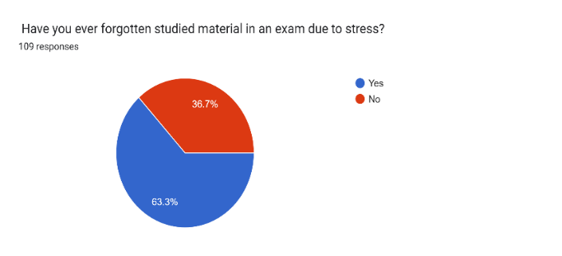
Conclusion: Most students (63.3%) reported forgetting studied material due to stress, while a smaller group (36.7%) did not face this problem.
Interpretation: Exam stress often impairs memory and concentration for most students, though a few remain unaffected due to better coping strategies.
- In your last major exam, how satisfied were you with your performance?
In your last major exam, how satisfied were you with your performance? | Number | Proportion %
Very satisfied | 37 | 33.9%
Satisfied | 48 | 44%
Dissatisfied | 10 | 9.2%
Neutral | 14 | 12.8%
Total | 109 | 100%

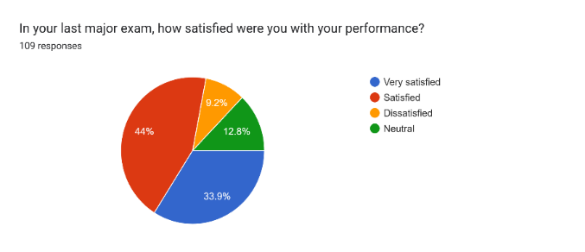Conclusion: Most students felt satisfied (44%) or very satisfied (33.9%) with their last exam performance, while fewer were neutral (12.8%) or dissatisfied (9.2%).
Interpretation: Most students felt positive about their performance, though a few expressed dissatisfaction or uncertainty.
- Which coping methods do you use during exams?
Which coping methods do you use during exams? | Number | Proportion %
Time management / study schedule | 68 | 51.9%
Group study / peer support | 23 | 17.6%
Meditation / relaxation techniques | 12 | 9.2%
Counseling services | 6 | 4.6%
Social media / entertainment | 11 | 8.4%
Other | 5 | 3.8%
Total | 109 | 100%

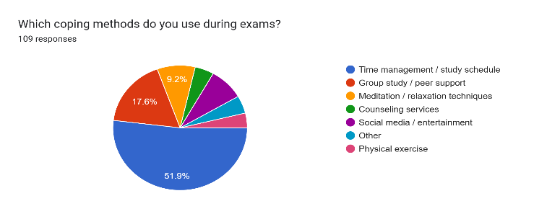Conclusion: The most common coping strategy is time management/study schedules (51.9%), followed by group study (17.6%). Fewer students use meditation (9.2%), social media/entertainment (8.4%), counseling (4.6%), or other methods (3.8%).
Interpretation: Most students cope with exam stress through study schedules, with fewer using relaxation or counseling, showing a focus on academic strategies.
- Rate your overall exam stress level on a scale of –
Rate your overall exam stress level on a scale of - | Number | Proportion %
1 | 12 | 11%
2 | 22 | 20.2%
3 | 32 | 29.4%
4 | 28 | 25.7%
5 | 15 | 13.8%
Total | 109 | 100%

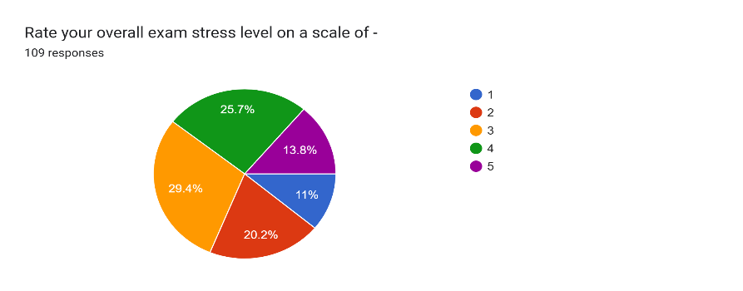
Conclusion:Most students rated their exam stress as moderate (29.4%) or high (25.7%), while fewer reported low (11%, 20.2%) or very high (13.8%) stress levels.
Interpretation: Exam stress is common, primarily moderate to high, with fewer students experiencing extreme levels.

- How often do you feel overwhelmed or unable to cope with study load before exams?
How often do you feel overwhelmed or unable to cope with study load before exams? | Number | Proportion %
Never | 22 | 20.2%
Always | 30 | 27.5%
Rarely | 33 | 30.3%
Sometimes | 24 | 22%
Total | 109 | 100%

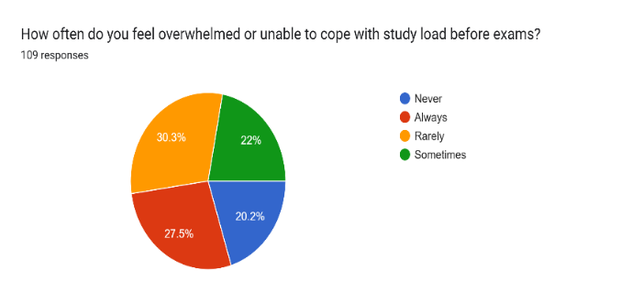Conclusion: The largest group felt overwhelmed rarely (30.3%), followed by always (27.5%), sometimes (22%), and never (20.2%).
Interpretation: Most students feel overwhelmed by exam stress to varying degrees, with many experiencing it consistently.
- Does your institution provide counseling or stress management programs?
Does your institution provide counseling or stress management programs? | Number | Proportion %
Yes | 35 | 32.1%
No | 43 | 39.4%
Not Sure | 31 | 28.4%
Total | 109 | 100%

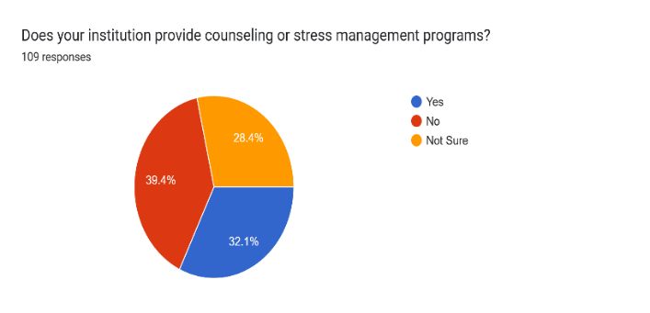Conclusion: Around 32.1% of students said their institution offers counseling, 39.4% said no, and 28.4% were unsure.
Interpretation: The data shows limited access or awareness of stress management programs, revealing a gap in institutional support.
- How helpful would it be if your college organized stress management workshops before exams?
How helpful would it be if your college organized stress management workshops before exams? | Number | Proportion %

Not helpful | 32 | 29.4%
Very helpful | 77 | 70.6%
Total | 109 | 100%

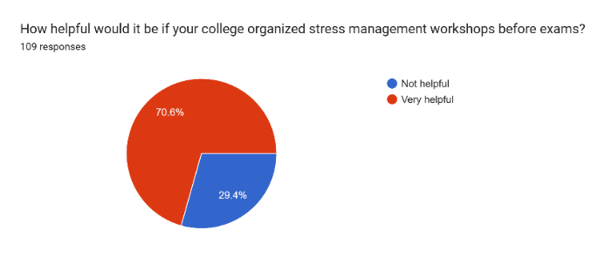Conclusion: A majority of students (70.6%) felt stress management workshops would be very helpful, while 29.4% considered them not helpful.
Interpretation: Findings indicate strong student demand for stress management workshops to help reduce exam stress.
Findings:
- Demographics: Majority male (51.4%), postgraduates (27.5%), mainly from Science (43.1%) and private institutions (72.5%).
- Major Stressors: Main causes were lack of preparation time (42.2%) and poor time management (21.1%); 36.7% sometimes feared failure.
- Physical & Emotional Impact: 35.8% sometimes had sleep difficulties; 63.3% forgot studied material; 27.5% always felt overwhelmed.
- Coping Strategies: Most used time management/study schedules (51.9%) and group study (17.6%); only 4.6% used counseling.
- Institutional Support: 39.4% reported no counseling programs; 28.4% unsure; 70.6% favored stress management workshops.
- Stress Levels & Performance: Stress mostly moderate (29.4%); 44% were satisfied with exam performance despite stress.
Suggestions:
- Institutional Interventions: Organize stress management workshops and establish counseling cells with trained professionals.
- Stress Levels & Performance: Stress mostly moderate (29.4%); 44% were satisfied with exam performance despite stress.
- Suggestions: Policy Recommendations: Implement balanced evaluation systems and integrate mental health awareness programs.
- Parental and Teacher Role: Raise awareness about the impact of pressure and foster a supportive, holistic learning environment.
Conclusion:
The study confirms that exam stress significantly impacts students’ academic performance, emotional well-being, and overall health. Lack of preparation time, fear of failure, and parental/societal expectations are the primary stressors. While many students adopt coping strategies such as time management and group study, institutional support remains insufficient, with limited access to counseling or structured stress management programs.
References: 1) Kumari, A., & Singh, S. K. (2022). Academic Stress among Senior Secondary Students with Reference to Gender, School Type, and Stream. Kala Sarovar, 25(04).
2) Lin, Jing and Chen, Qinghai (1995). “Academic Pressure and Impact on Students Development in China”, MCGILL Journal of Education, Vol. 30, No.2, pp.149-168.
3)Prabu, P. S. (2015). Academic Stress in Senior Secondary Students: Influence of Gender, School Type, and Academic Stream. International journal of humanities and social science invention, 4(10), 63-68.
4).Lee, M., & Larson, R. (2000). The Korean "examination hell": Long hours of studying, distress, and depression. Journal of Youth and Adolescence, 29, 249-27
5)Kumari, A. & Gartia, R. (2012). Relationship between stress and academic achievement of senior secondary school student.

